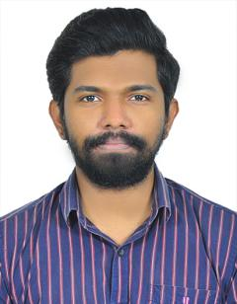

JULIAN DANIEL VARGHESE

Client Service Executive

Email:  juliandv2011@gmail.com  Contact No: +91 9778371571  Personal Details:  Nationality: Indian.  Date of Birth: 31-10-1993.  LinkedIn:  linkedin.com/in/julian-daniel-varghese-29890bab  Languages Spoken:  English, Malayalam , Tamil | Profile  3 years fostering strong client relationships & exceeding expectations. Deliver impactful digital solutions through seamless teamwork & data-driven strategies.  Employment History  - Monolith Marcom Pvt Ltd. | Client Service Executive  ( 2021 – Present )  - Gathered in-depth requirements, collaborated with teams to build impactful strategies, and selected optimal platforms based on audience analysis.  - Steered clients through social media onboarding, facilitated online integration, and provided ongoing guidance.  - Addressed client concerns through open communication and collaborative solutions, ensuring campaign satisfaction.  - Generated detailed reports, analyzed data for actionable insights, and drove continuous campaign improvement.  - Fostered strong client relationships through open communication, proactive support.  Education  - Bachelor of Technology | Vellappally Natesan College of Engineering ( 2011 – 2015 )  B.Tech graduate in Computer Science Engineering with a CGPA of 6.26  - Higher Secondary Education | Cherupusha Bethany Senior Secondary School ( 2010 – 2011 )  Achieved a 68.4% aggregate in HSC examinations (C.B.S.E.)  Skills  - Communication Skills  - Client relationship management  - Project management  - Digital marketing skills  - Analytical and problem-solving skills  - Organization and time management
Strengths

- Client service :
- Building trust and rapport with clients
- Clear and concise communication
- Proactive problem-solving

- Project management :
- Prioritizing tasks and meeting deadlines
- Adapting to changing priorities
- Collaborating effectively with team members

- Technological skills :
- DNS, Https
- Meta Ads Manager, Google Analytics
- ChatGPT, Bard

- Soft skills :
- Positive and enthusiastic attitude
- Strong work ethic and dedication
- Open-mindedness and willingness to learn

